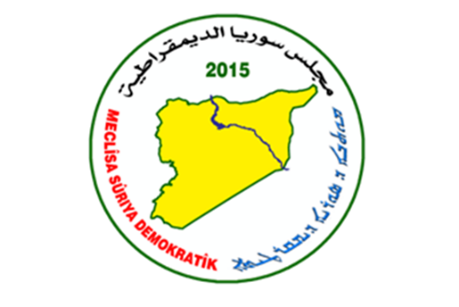

Afrin Al , Shahba Center

Office of Relations

Report of violations against the people of Afrin province

In this report, we review a series of crimes and violations practised by the Turkish occupation army and its armed factions/mercenaries in the occupied city of Afrin from **16/12/2023 to** 30-12-2023**.**

Kidnapping:

On 19.122023. A patrol of the Turkish occupation intelligence, accompanied by members of the mercenaries of the military police of the Turkish occupation, kidnapped a Kurdish woman from the village of Zeitounaka in the Shara / Sharran district, called:

● Najla Hanan Sheikh Ismailzadeh (36) years old, and lives in the village The citizen Najla  
  
was kidnapped without her family knowing the reason for her abduction. she was transferred to an unknown destination and her fate is still unknown.   
  
Our network published on 24.12.2023.News that on 17/12/2023, the intelligence of the mercenaries of the civil police of the Turkish transparency kidnapped (a member of the local council of Sharran) affiliated with the Arabs from the village of Zeitounaka in the district of Sharra / Sharan, called:

■Sheikh Saeed Sheikhzadeh.

Mr. Zadeh is accused of involvement in the kidnapping of his relative, Engineer Sheikho Haj Ahmadzadeh Abu Jameel, 59, from the village of Zeitounaka who was kidnapped on Friday on 29.9 2023. At 11 am when he was heading from the occupied city of Afrin to his village of Zeitounakeh.   
  
But the real reason behind the kidnapping of citizen Sheikh Saeed is his strong disagreement with the commander of the elite army mercenaries, Moataz Raslan, over the income of the lands of the Aghas seized by the mercenaries with the participation of the kidnapped citizen.

- On 25.12.2023, members of the military police mercenary checkpoint at the entrance to the occupied city of Afrin, Mahmoudiya checkpoint, kidnapped a Kurdish citizen from the village of Dikih in the district of Balbala / Bulbul, claimed: ■Shaaban Rashid Hamo (25) years old. The mercenaries kidnapped the Kurdish citizen Shaaban, on charges of belonging to People's Protection units and his participation in fighting with them, He was taken to an unknown destination, and his fate is still unknown.

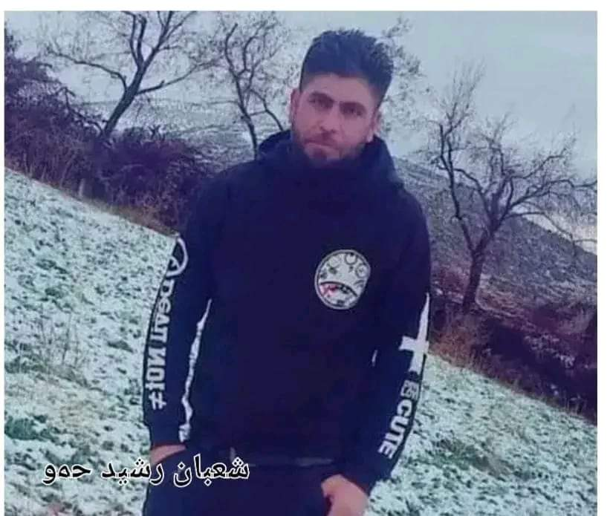  
  
  
  
- About twenty days ago, mercenaries of the military police of the Turkish occupation at the entrance to the city of Afrin kidnapped a Kurdish family from the village of Hegche in the district of Jindrisa / Jindires while they were trying to reach their hometown coming from areas of forced displacement and the abductees are:  
   
 ■Mustafa Muhammad Maho (65) years old

■Farida (60) years old, wife of (Mustafa Maha)   
■Bareen Walid Mustafa Maho (12) years old, grandson of {Mustafa Maha}  
  
■ Muhammad Mustafa Maho (23) years old  
■Fidan Abdul Rahman Mustafa (20) years old, wife of (Muhammad Mustafa Maha) and their two young children.  
  
The next day, Mustafa Maha's second son, Rifai Mustafa Muhammad Maho (32) was kidnapped from their village in the next day. The mercenaries later released the kidnapped citizen (Farida), her daughter-in-law (Fidan) and her two children, while the rest are still unknown until now.

* On 21/12/2023, mercenaries of the military police of the Turkish occupation kidnapped a Kurdish citizen from the village of Darkaria in the Maabatli district.

■Abdo Mohammed, 32, nicknamed Abdo Arab

The mercenaries kidnapped Abdo four months after his arrival in his hometown from the areas of forced displacement.

- On 12.242023, the military police mercenary checkpoint of the Turkish occupation at the entrance to the city of Afrin_at the Mahmoudia checkpoint kidnapped a Kurdish citizen from the village of Sheikh / Al-Shuyoukh of Rajo district called:

■Hanan Sheikh Fakhri

The mercenaries kidnapped the citizen while arriving in the occupied city of Afrin coming from his village, where he was transferred to an unknown destination and his fate is still unknown until now, it is known that the Kurdish citizen (Hanan) had arrived in his hometown about five months ago from Turkey.

* On 17/12/2023, the Kurdish young man Ahmed Muhammad Duran Majeed, 26, from the village of Arab Wiran, in the occupied district of Sharan Afrin, died in one of the hospitals in the Turkish city of Gaziantep, and after handing over his body to his family, he was transferred to his hometown, his family examined his body, and it was found that all his internal organs were stolen by the human organ traders in Turkey in agreement with the hospital's doctors.

- On 23.12.2023, mercenaries of the military police of the Turkish occupation kidnapped three Kurdish citizens, including an elderly man from the village of Darkrih in the Mabata / Maabtali district, and they are:

■ Sabri Mustafa Shasho {65} years old

■Mustafa Muhammad Ahmed {23} years old ■Bashar Muhammad {22} years  
 The mercenaries kidnapped the three citizens on charges of dealing with the former Autonomous Administration.   
it is worth noting that the kidnapped Kurdish elderly Sabri Shasho was previously kidnapped on 15/5/2022 on charges of going out in shifts guarding the village during the rule of the former Autonomous Administration, which is one of the incorrect ready-made charges used by mercenaries to kidnap citizens in the city of Afrin, where he was released after his family paid a ransom at the time in exchange for his release.

* On 19.12.2023, mercenaries of the military police of the Turkish occupation kidnapped a Kurdish woman and her seven-year-old child, from Maabatli district, called:
* ● Jihan Ahmed (39) years old the mercenaries kidnapped the Kurdish woman Jihan while she was in Ibn Sina Hospital in the city of Afrin.

She was transferred to the headquarters of the mercenaries in the city, and her young child was released several hours after his abduction, while the Kurdish citizen is still unaccounted for.

- The Turkish occupation mercenary court in the city of Azaz in the northern countryside of Aleppo issued a three-year prison sentence in addition to imposing a fine of 1500 US dollars on a Kurdish citizen from the village of Dikieh in the Rajo district, and he claims:

■Ahmed Qader Habash, 45 years old,

Mr. Habash was kidnapped in May 2023. In the city of Azaz, while he was on his way from the city of Aleppo to the city of Azaz in an attempt to cross the Syrian-Turkish border from the city of Azaz, where he was kidnapped by the military police of the Turkish occupation in the city, the kidnapped Kurdish citizen Habash was transferred from Azaz prison to the notorious Al-Rai prison.

Royalty fees:   
- Sultan Murad's mercenaries affiliated with the Turkish occupation and controlling the neighbourhood surrounding Nowruz roundabout in the city center of Afrin imposed a financial royalty of (3) thousand US dollars on a Kurdish citizen called:

■Muhammad Zakaria, in exchange for allowing him to establish a residential building near the Nowruz roundabout, he was threatened if he did not pay the royalty imposed on him, they would not allow him to establish the building, forcing the citizen Zakaria to pay the imposed royalty fees.  
   
  
Seizure:   
A Kurdish citizen had a stroke as a result of the imposition of large royalty fees on him. The Kurdish citizen Farah al-Din Hassan Ibrahim, 42, nicknamed Farah al-Din Haskilo from the village of Hikjah in the Jindrisa / Jindires district, suffered a stroke after the so-called security office led by the mercenary Saif al-Jassem, brother of the mercenary leader Abu Amsha, commander of the infantry mercenaries, was imposed on him. A large royalty fee of 15 thousand US dollars As a result of his inability to pay this large royalty, the mercenaries threatened him with kidnapping and death. in addition to kidnapping his family if he did not pay the royalty, which led to his stroke, and he was transferred to a hospital in the city of Afrin and is now lying in intensive care.   
  
It is worth noting that on 28.04.2023, the citizen Farah al-Din was kidnapped along with a number of his villagers after raiding their homes by mercenaries of the military police and the mercenary of the infantry, and he was released on the same day at that time after paying the ransom of 5 thousand of Turkish liras.   
  
The infantry mercenaries also kidnapped the wife of Mohammad Mostafa Fade (34 years old) and his children as hostages to surrender himself, forcing him to surrender himself to the infantry mercenaries in exchange for the release of his wife and children, and his fate is still unknown until now.   
  
 On 16.12 2023, the infantry mercenaries raided the homes of citizens in the village of Hikja, especially those who did not pay the royalties imposed on them, and as a result, most of those who did not pay the royalty fled from their homes, and among those who fled was the citizen (Muhammad Mustafa Mahho).

Logging:

- About two weeks ago, Sultan Murad's mercenaries of the Turkish occupation cut down (105) olive trees owned by citizens of the village of Kafr Jana in the Sharra / Sharan district, and they are:

■Hanan Hamdoush {50} olive tree

■Rashid Aybash Hamdoush {20} olive tree

■Rohad Shabab {20} olive tree from the Hamdoush family

■Mustafa Shabab {15} an olive tree from the   
 Doshham family

The mercenaries have cut down these trees using electric saws under the supervision of the Turkish occupation forces who have an army base near those fields that have been cut down.

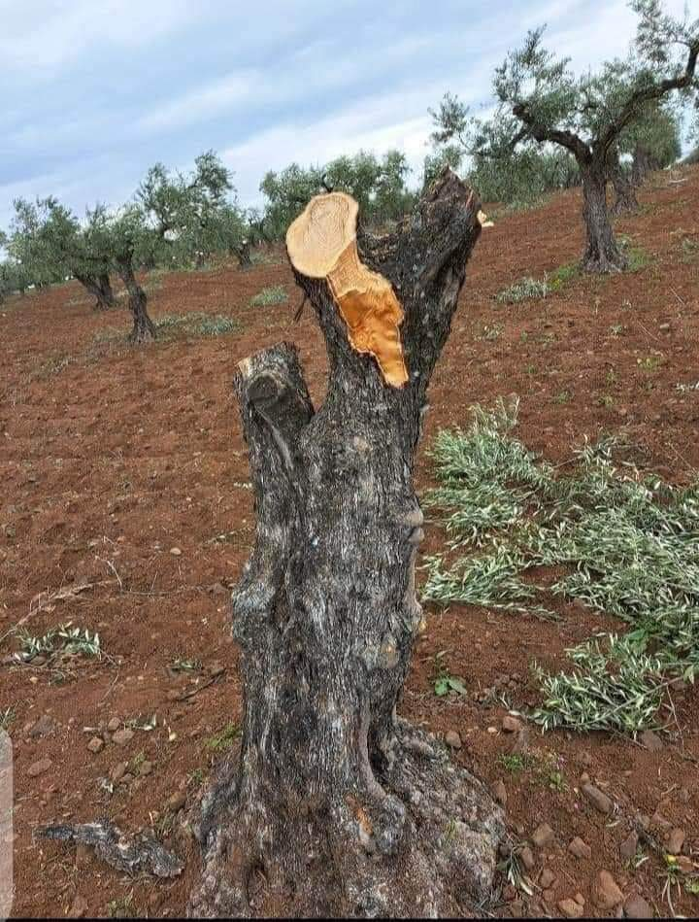  
  
  
- Sultan Murad mercenaries of the Turkish occupation cut down (185) olive trees owned by three citizens from the village of Qastal _Kishk in the Sharra / Sharan district, and they are:  
  
 ■Mustafa Abdo Sheikh Naasan 75 olive trees ■Anwar Sabri Sheikh Naasan 60 olive trees

■ Muhammad Kamal Youssef 50 olive trees   
The mercenaries woodworking these trees and transporting them to local markets to be sold there without any deterrence by the competent authorities of the Turkish occupation.

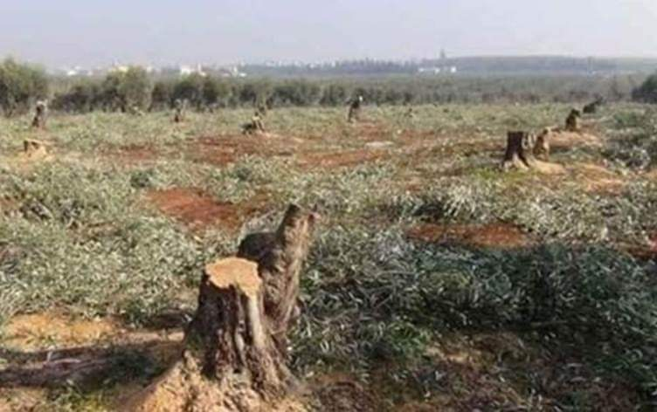

Settlement:

Since its occupation of the city of Afrin, the Turkish occupation has been working aggressively and under the name of charitable and humanitarian work on the demographic change of the occupied city of Afrin to erase the Kurdish identity of the region. The Muslim Brotherhood's regional association Helping Hand, in coordination with the Turkish organization AFAD and the local council of the Turkish occupation, recently opened two settlements. Helping Hand Settlement 1 and 2, the first is located in the Sharra/Sharan district and the second is near the centre of the city of Afrin, where each settlement consists of 250 residential apartments serviced by schools, mosques and health center.

The opening of the two settlements was attended by Mustafa Polat, director of the Turkish Seven Sanabel Association, and Yasser al-Khouli, regional director of the Muslim Brotherhood's "Helping Hand" association and official of the Turkish AFAD organization in the occupied city of Afrin.

